Bangla Voice CRM Management
System Design Diagrams
Architecture, data flow, module, ER, deployment, and pipeline visuals
Date: 02 May 2026

1. High-Level Architecture Diagram
This figure shows the full client-server architecture of the Bangla Voice CRM Management system, including mobile app modules, backend ASR pipeline, CRM extraction, intelligence, and local storage.
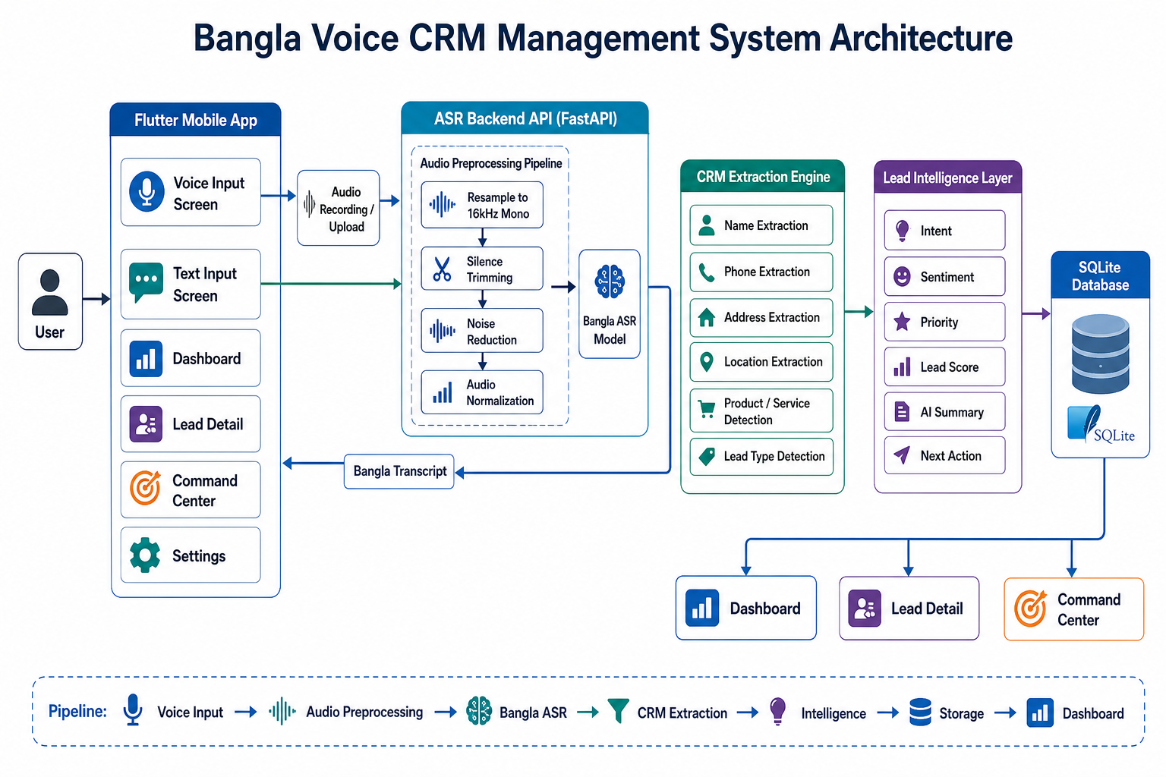
Figure 1: High-level system architecture for Bangla Voice CRM Management.

2. Data Flow Diagram (Level 1)
This diagram shows how user input flows through the system and becomes a structured CRM lead.
User | → | Voice / Text Input
Voice / Text Input | → | Speech-to-Text Processing
Speech-to-Text Processing | → | CRM Field Extraction
CRM Field Extraction | → | Lead Intelligence
Lead Intelligence | → | SQLite Lead Database
SQLite Lead Database | → | Dashboard / Lead Management
Figure 2: Data flow diagram showing the main processing stages.

3. Detailed Processing Pipeline
This pipeline focuses on the voice-input path from recorded audio to saved lead.
Bangla Voice Input | → | Audio Recording
Audio Recording | → | Audio Preprocessing
Audio Preprocessing | → | Bangla ASR
Bangla ASR | → | Bangla Transcript
Bangla Transcript | → | CRM Extraction
CRM Extraction | → | Validation + Confidence
Validation + Confidence | → | Lead Intelligence
Lead Intelligence | → | SQLite Storage
SQLite Storage | → | Dashboard / Command Center
Figure 3: End-to-end processing pipeline.

4. Module Diagram
This diagram groups the system into functional modules for implementation and maintenance.
Flutter App | Input Module | CRM Processing Module | Lead Intelligence Module | Database Module | Presentation Module
 | Voice Input  Text Input  Settings | Normalization  Field Extraction  Validation  Lead Type Detection | Intent  Sentiment  Priority  Lead Score  Summary | Insert  Search  Update  Export | Dashboard  Lead Detail  Command Center
Figure 4: Functional module design of the system.

5. Entity Relationship (ER) Diagram
The current prototype stores one main business entity: the CRM lead.
LEAD
id (PK)
leadId
dateTime
leadType
name
phone
address
location
productInterest
transcript
status
confidence
intent
sentiment
priority
leadScore
aiSummary
nextAction
Figure 5: ER diagram for the lead entity.

6. Deployment Diagram
This view shows where the system components run in the prototype deployment setup.
Mobile User | → | Flutter Mobile App | → | ASR Backend Server
ASR Backend Server | → | Audio Preprocessing | → | BanglaASR Model
Flutter Mobile App | → | Local SQLite Database | → | Dashboard / Lead Detail / Command Center
Figure 6: Deployment layout for client, backend, and storage.

7. Input Path Comparison
The system supports both voice-based and direct text-based workflows.
Voice Path | Text Path
User speaks in Bangla  → Audio upload  → Preprocessing  → Bangla ASR  → Transcript  → CRM Extraction  → Intelligence  → Save Lead | User pastes Bangla text  → CRM Extraction  → Intelligence  → Save Lead
Figure 7: Comparison between voice and manual text workflows.

8. Design Summary
The system design follows a layered client-server architecture. The Flutter mobile app manages user interaction and CRM presentation, the backend handles audio preprocessing and speech recognition, the extraction engine converts transcripts into structured lead data, the intelligence layer enriches each lead, and SQLite stores the final result for dashboard and management views.

